**SUPPLEMENTARY FIGURE S9: Cost analysis by patient segment**

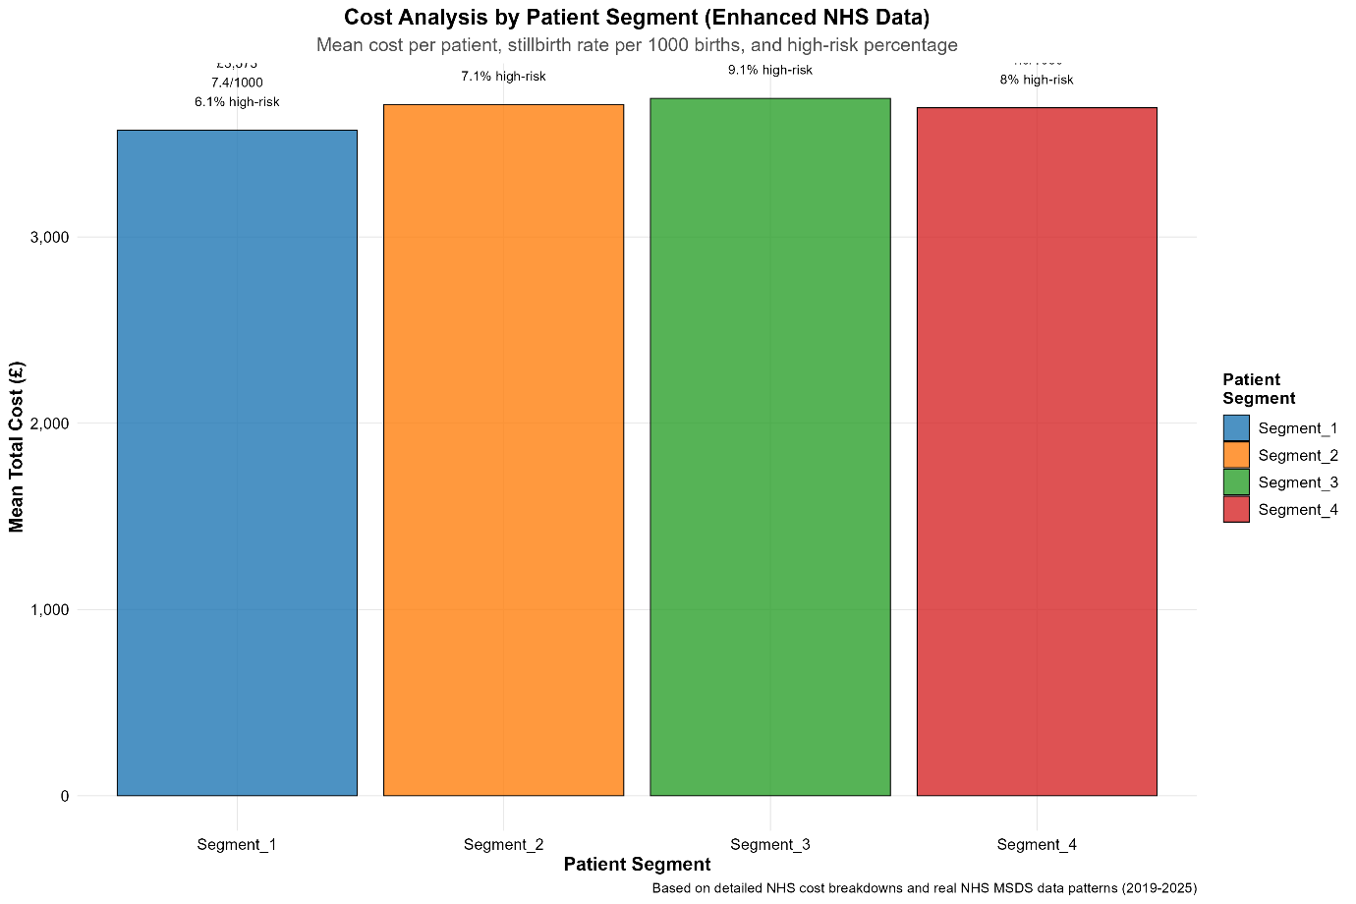

Mean healthcare cost per patient across four identical patient segments, with corresponding stillbirth rates and high-risk percentages. Segment 3 (Lower Risk advantaged) shows highest costs despite lowest risk profile, reflecting appropriate resource allocation for complex but manageable cases. Segments 1 and 2 ( high deprivation) show elevated risk profiles justifying enhanced resource allocation.